**90Th Percentile response times Screen shot from Html report-**

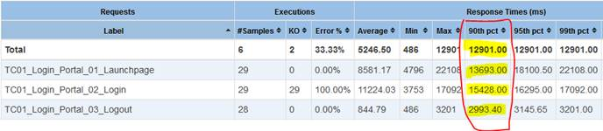

90Th Percentile response times screen shot from Aggregate report(From JMeter)-

